**EDA Project -Northwind**

**Introduction**

The Northwind database contains the sales data for a fictitious company called “Northwind Traders,” which imports and exports specialty foods from around the world. The Northwind database is an excellent tutorial schema for a small-business ERP, with customers, orders, inventory, purchasing, suppliers, shipping, employees, and single-entry accounting.

**Questions**

* What are the most requested cities from Northwind for '2012'year ?
* How much is the total orders per '2012' year?

**Data Description:**

The database represents 13 tables Products ,orederr ,Suppliers ,Employees ,Customers ,OrderDetail and more .The table Orders have a 14 columns is OrderID ,CustomerID ,EmployeeID ,OrderDate ,RequiredDate ,ShippedDate ,ShipVia ,Freight ,ShipName ,ShipCity ,Shipregion ,ShipPostalCode ,ShipCountry. The table OrderDetails have a 6 columns Id, OrderId,ProductId ,UnitPrice ,Quantity ,Discount .

Orderr The columns = 14 and the rows = 16818 ,OrderDetail The columns = 4 and the rows = 621883

**Design**

We will open a NorthWinds convenience store, and we will be looking for cities with high income, high order numbers, and most profitable cities during 2012.

### Algorithms

Perform a thorough Exploratory Data Analysis of the Northwind data; clean, explore, aggregate, and visualize the data as appropriate .

### Tools

* ***Programming:*** SQLite , Python .
* ***Libraries:*** Numpy ,Pandas ,Matplotlib ,Random ,seaborn.

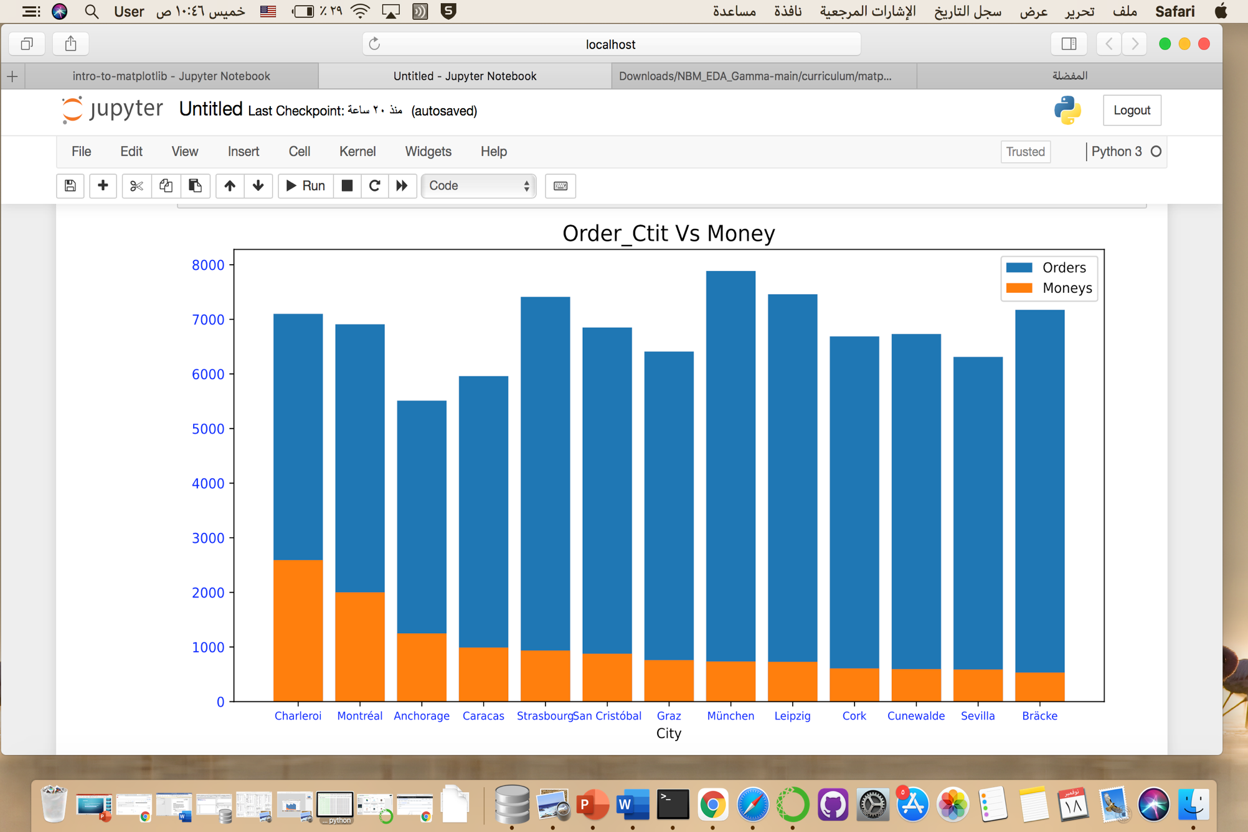**Visualization**

**Result**

1. Opening of the shop in the city of Charleroi, cities with high income and average demand.
2. Other cities such as München and Bracke have the highest orders , but their income is small and it is possible to increase declarations for products.